**Spring JPA Data**

Spring JPA data is another spring module which is base upon JPA. Spring JPA data module provide complete abstraction for DAO or ORM layer.

Spring JPA Data is base upon Java 8 features.

From Java 8 onward interface can contains method with body. Those method must be default or static.

interface Bank {

public abstract void withdraw();

public abstract void deposit();

public default void gst() { you can override if don’t like

System.out.println(“default implementation”)

}

public static void loan() { you can’t override

System.out.println(“static implementation”);

}

}

Spring JPA data provided two pre defined interface.

CrudRepository : generic repository

JpaRepository : jpa specific repository

@Repository

public interface ProductRepository extends JpaRepository<EntityClassName,PrirmaryKeyColumnDataType> {

}

**Creating rest api for product and orders entity with spring jpa data**

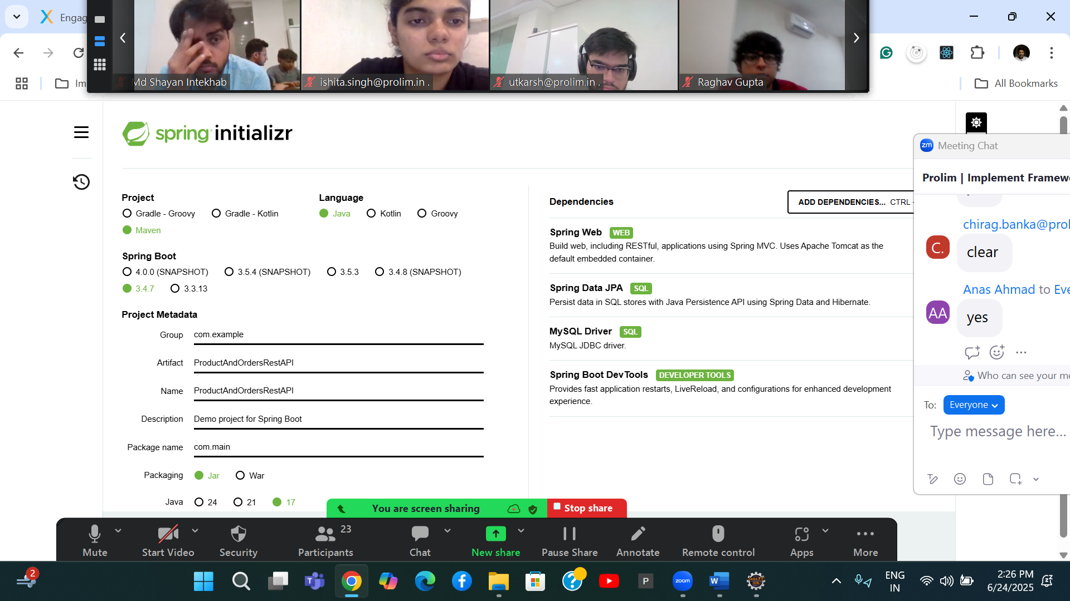

**Product**

Pid(PK), PName, price, qty etc

100,TV, 45000, 10

Orders

Oid(PK) auto_increment, pid(FK), orderdataandtime,qty etc

1 , 100, 24-06-2025 with time , 2

2, 100, 24-06-2025 with time, 10

create table product(pid int primary key,pname varchar(30), price float)

create table orders(oid int primary key auto_increment, pid int, orderdateandtime datetime, **foreign key(pid) references product(pid));**

@RequestMapping annotation we can use on class level as well as method level

On class level to map root or base path.

On method level we need to map sub path with method attribute

@PostMapping

@GetMapping

@PutMapping

@DeleteMapping

@PatchMapping

These all annotation we can use on method level without method attribute.

Spring micro service

**Micro Service:** Small service.

Product

Login

Order

Payment

Manager

Etc

Product module Customer Module Login module

Feedback module payment module

Once we merge the code of all developer we need to re-build the project and deploy we need to create jar or war file.

Micro service : in micro service rather than developing whole application we develop only small part of the application. Those application develop using same language or different language using same database or different database. We deploy those small module independently in separate jar or war file.

Login module -🡪using spring boot with database is my sql and deploy on port number 8080

Customer module -🡪 using spring boot with database is my sql and deploy on port umber 8181

Payment module -🡪 using python with Django framework with database as mongo db deploy on port number 8282

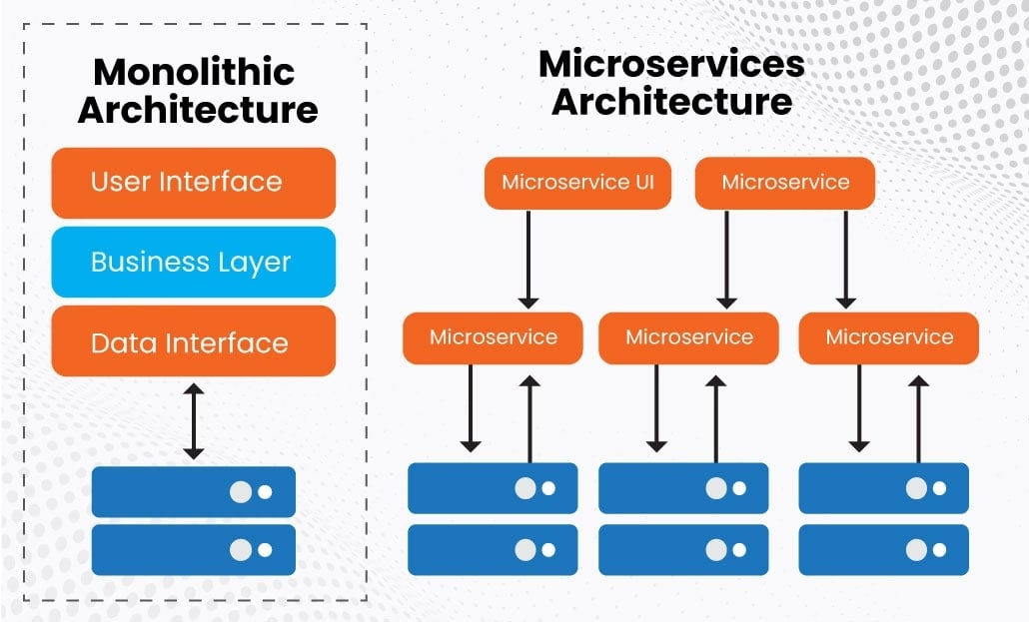

Spring boot provided new module is

Spring cloud

Spring provided one the open source server ie Eureka Server . it is a type of open source server which help deploy more than one micro service project creating using spring boot as well as other technologies.

Role of the Eureka Server is maintain life the each micro service project.

Eureka Server by default run on port number 8761

1. First micro service 8181
2. Second micro service 8282
3. Third micro service 8383